**ABSTRACT**

This project report covers all required activities and sort of equipment and problem solving regarding daily exchange of money using tap and pay procedure. After breakdown of COVID-19, government and whole world imply contactless payment measures as one of major approach to avoid covid 19 contamination. We developed this project in line with solving such issue by providing a secure and safe to pay without any other issue. To sum up, this report covers everything regarding tap and pay system which made of two major parts which are software and hardware parts. It is about the payment system using card, this will facilitate in payment system here in our country by reducing the time consumption and help the seller that uses it to keep record of transactions made.

My project has three main parts which are: RFID system, Arduino microcontroller and computer part which is composed by program and database.

**WORKING PRINCIPLE**

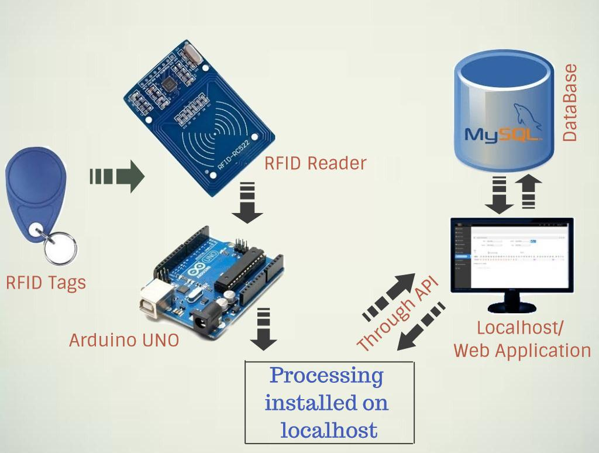

**Figure 17: working principle**

After the RFID card or tag is approached around the RFID reader it will be read and sends the card identification to the arduino microcontroller which will also sends it to the application software designed in processing using java language. Then the card ID will be sent to the system website to be checked whether if it is in database as registered card if yes, the website will be opened automatically and you can enjoy the system, otherwise it will show you that you are unknown user.

**Entity Relationship Diagram**

**Symbols:**

* **Entity**: is an existing, object, concept or real thing that is uniquely identifiable where is used for storing the organizational data.

Its symbol is a box:

* **Attribute**: is a part of the description of the entity. The entity itself is described by one or more attributes together; they describe all things of importance about the entity.

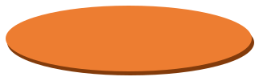Its symbol is an oval:

* 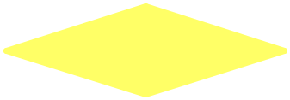**Relation**: is an association between several entities; it is on ordered pair consisting of particular related entities.

Its symbol is a diamond:

* **Line**: is used to join entities to their attributes, and joining entities with their relations

Its symbol is a line:

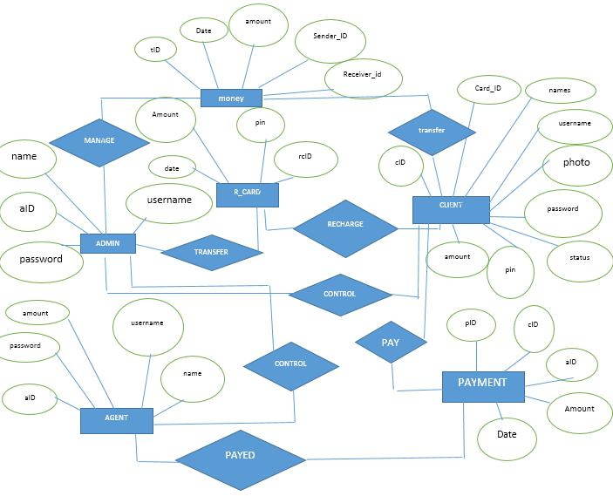

**Figure 10: entity relationship diagram**

**CIRCUIT/WIRING DIAGRAM**

